Role Play Script Template
Completed Example

Actor | Lines | Image or picture to support understanding of script content or emotions
Jose | What is your favorite thing about living in your neighborhood? | 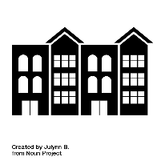
Adriana | I love being with my friends who live on my street. We hang out together | 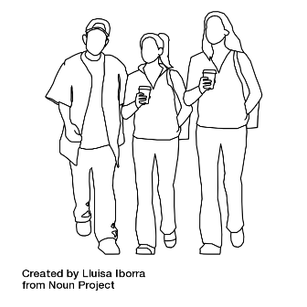
Miquel | My favorite restaurant. I love French fries. I also go there with my friends | 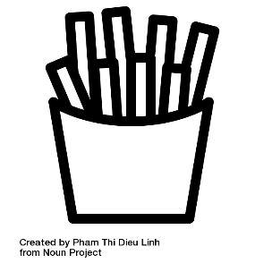
Jose | Why is it important to live near your friends?

Role Play Script Template
Blank

Actor | Lines | Image or picture to support understanding of script content or emotions

